January 2019

* National Birth Defects Prevention Month
  + Not all birth defects can be prevented. But you can increase your chances of having a healthy baby by careful management of conditions and by creating and maintaining healthy behaviors during pregnancy. Taking care of yourself and doing what’s best for you is also best for your baby! January is National Birth Defects Prevention Month, so you can join the nationwide effort to raise awareness of birth defects, their causes, and their impact. For more information, please visit: <https://www.cdc.gov/ncbddd/birthdefects/prevention-month.html>
* National Glaucoma Awareness Month
  + January is National Glaucoma Awareness Month, a productive time to spread the word about this sight-stealing disease. For more information please visit: <https://www.glaucoma.org/news/glaucoma-awareness-month.php>

Happening in Health this Month

────

National Drugs & Alcohol Chat Day

“National Drugs & Alcohol Chat Day is an annual live online chat held between high school students and NIDA scientists during National Drug and Alcohol Facts Week. Students from around the country ask the questions they most want the answers to about drugs and drug misuse, including drug effects, how to help friends or family that are abusing drugs, and what causes addiction.” For more Information please visit: <https://teens.drugabuse.gov/national-drug-alcohol-facts-week/chat-with-scientists>

────

Thyroid Awareness Month

January is thyroid awareness month, which is the perfect time for people to learn how to notice and identify symptoms of thyroid problems and how to combat thyroid disease. To learn more, please visit: <https://www.nchs-health.org/thyroid-awareness-month/>

620 SE Oak Street, Suite E, Hillsboro, OR 97123 | 503.747.3096

Pearlintegrativemedicine.com

Email us at info@pearlintegrativemedicine.com

***P***earl Integrative Medicine

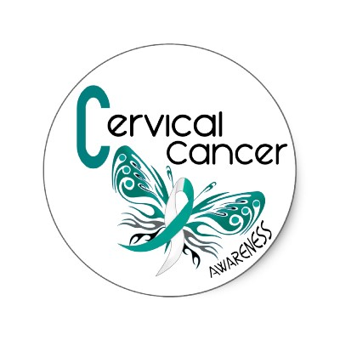

[This Photo](http://ugandajournalistsresourcecentre.com/op-ed-can-prevent-cervical-cancer/) by Unknown Author is licensed under [CC BY-NC](https://creativecommons.org/licenses/by-nc/3.0/)