November 2018

* Diabetes Awareness Month
  + During the month of November, join the national effort to raise awareness of diabetes, which effects tens of thousands of people each year. For more information on how to get involved, managing diabetes, and ways to support the month of diabetes awareness, please visit <http://www.diabetes.org/in-my-community/american-diabetes-month/>
* Lung Cancer Awareness Month
  + Join us in helping to raise awareness about lung cancer during November’s Lung Cancer Awareness Month! For more information please visit, <http://lcam.org/>
* Pancreatic Cancer Awareness Month
  + November is National Pancreatic Cancer Awareness month. Help raise awareness in our community, one person at a time. For more information, please visit: <https://www.pancan.org/news/pancreatic-cancer-awareness-month/>

Happening in Health this Month

────

Diabetes Awareness Sessions

Want to know more about managing diabetes for yourself or a loved one? Visit the below website to learn more about meal planning, goal setting, exercise and more from experts at Adventist Health’s Diabetes and Endocrine Center:

<https://www.adventisthealth.org/Portland/event/diabetes-awareness-sessions>

────

Fighting Diabetes in the Kitchen

To ensure blood glucose and insulin levels are staying in check, November is the perfect month to talk about nutrition as an important aspect of managing diabetes. Visit:

<https://www.facebook.com/pg/Life-Changing-Dinners-160270744502751/events/?ref=page_internal>

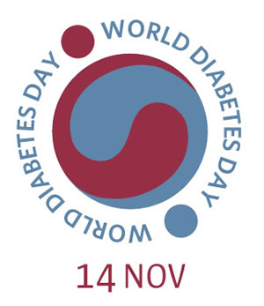

620 SE Oak Street, Suite E, Hillsboro, OR 97123 | 503.747.3096 Pearlintegrativemedicine.com

Email us at info@pearlintegrativemedicine.com

***P***earl Integrative Medicine, LLC