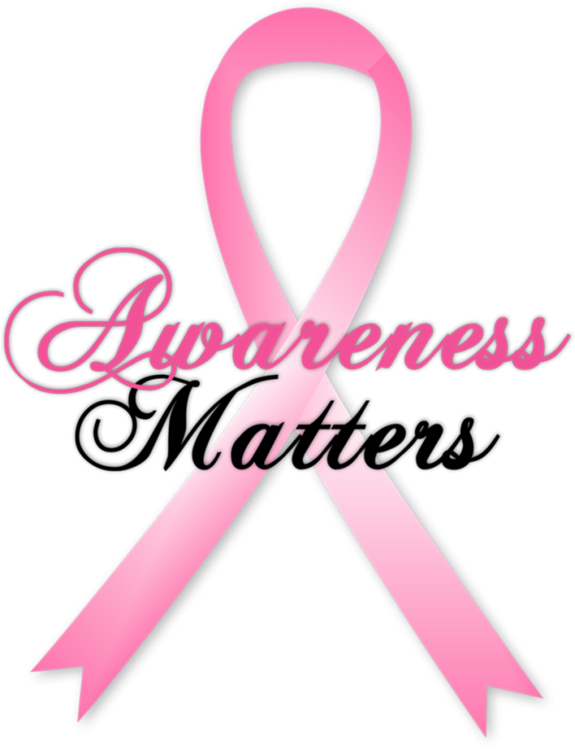

Happening in Health

this Month

────

2018 Annual Survivor & Friends Luncheon & Educational Sessions

────

October 27th , 2018  
Educational Break-Out Sessions 9:00am-11:00am with Dr. Dianna Henson, Megan Gardner and

Dr. Alex Speers  
Lunch & Vendors 10:30am – 2:00pm | Fashion Show by Chicos

Visit:

<https://www.breastfriends.org/sl-2018/>

October 2018

* Breast Health Awareness
  + October is national breast cancer awareness month. Help raise awareness of the disease in our community, one person at a time. For more information visit <http://www.nationalbreastcancer.org/breast-cancer-awareness-month>
* Diabetes Awareness Month
  + During the month of November, join the national effort to raise awareness of diabetes, which effects tens of thousands of people each year. For more information on how to get involved, managing diabetes, and ways to support the month of diabetes awareness, please visit <http://www.diabetes.org/in-my-community/american-diabetes-month/>
* Knitted Knockers
  + Knitted Knockers are special handmade breast prosthesis for women who have undergone mastectomies or other procedures to the breast. They help connect volunteer knitters with breast cancer survivors to offer free Knitted Knockers to any woman who wants them. For more information, visit <https://www.knittedknockers.org/>

***P***earl Integrative Medicine, LLC

620 SE Oak Street, Suite E Hillsboro, OR 97123 | 503.747.3096 Pearlintegrativemedicine.com

Email us at info@pearlintegrativemedicine.com